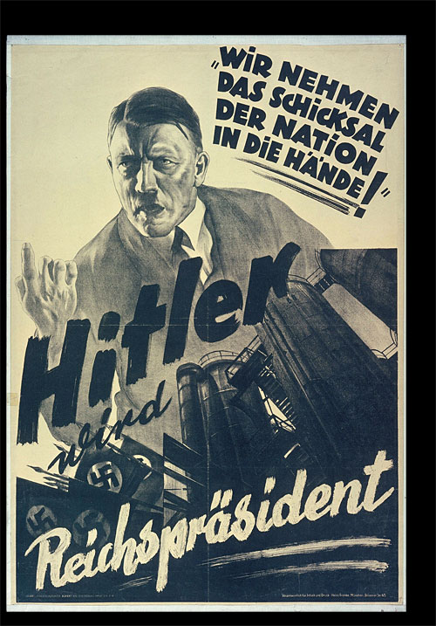

**Source 1**: Nazi propaganda poster created in 1932, just before the Nazi party won the largest number of seats in the Reichstag.

The text translates to ‘Hitler will become President’ and “We are taking the fate of the nation into our own hands”

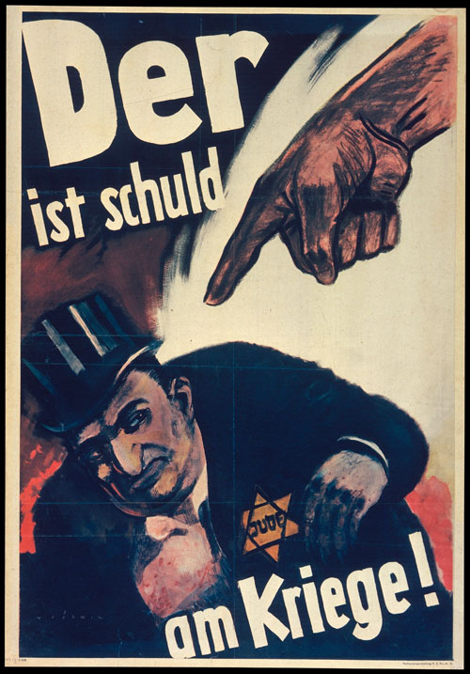

**Source 2**: Nazi propaganda poster created in 1943. The translation is ‘The war is his fault!’.

**Source 3**: An American cartoon commenting on the Treaty of Versailles, published by the New York World in 1921.

